# Project Name: Displaying User Feedback.

## Output:

### Landing Page:

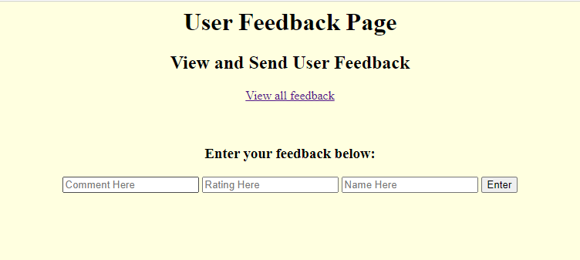

### Entering Feedback:

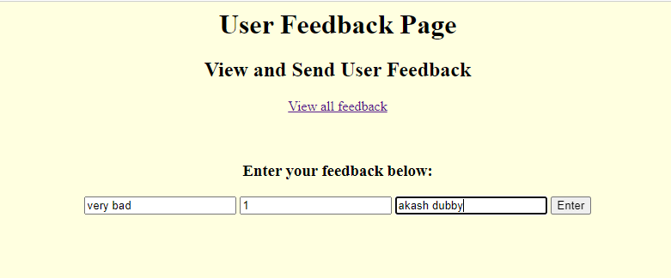

### On Successful feedback:

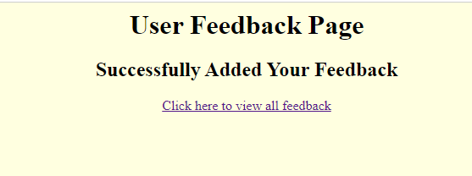

### All Feedback Given Table:

